How to create environment in Elastic beanstalk
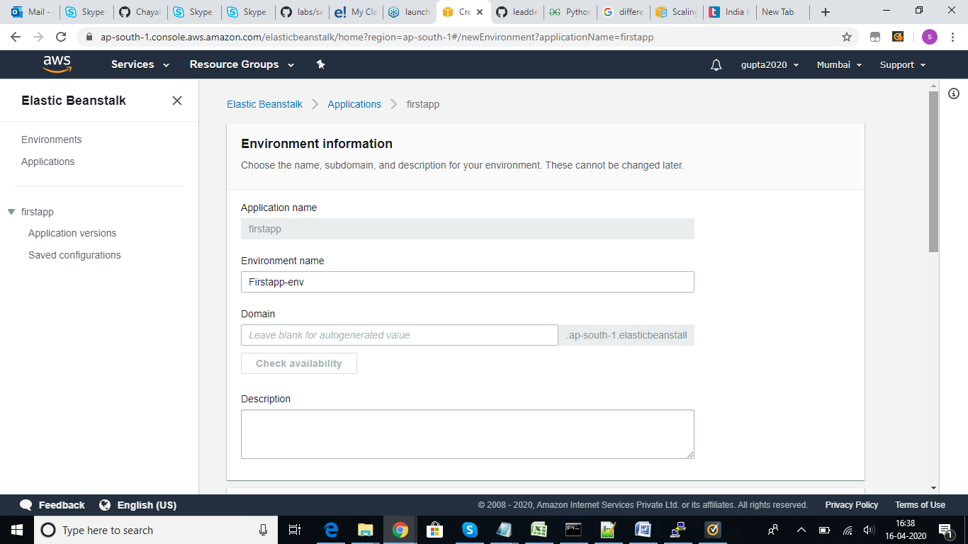

Update the environment name and update the plaform type and select the required one
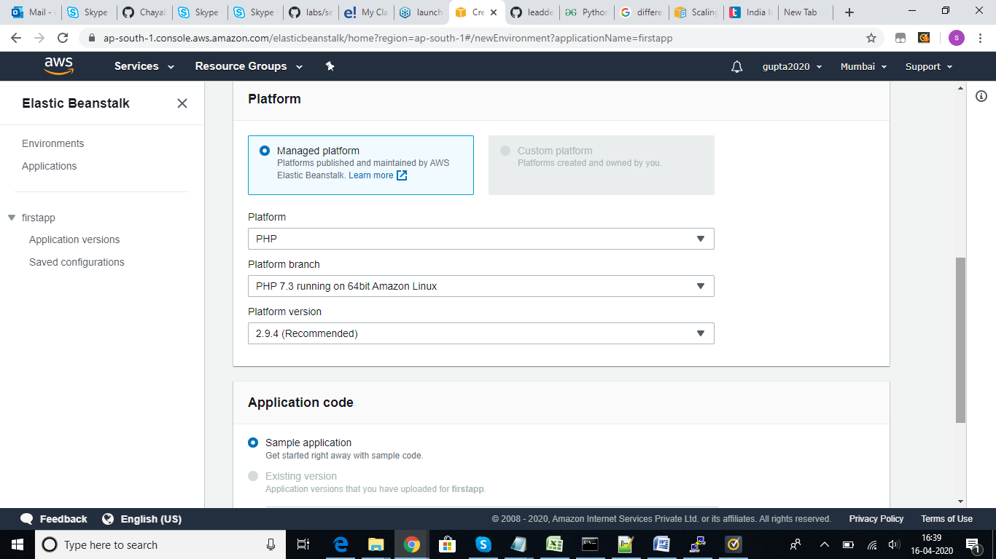

Once you select the platform type you can select sample application for testing or you use your own code if you have any and upload then click on create environment.
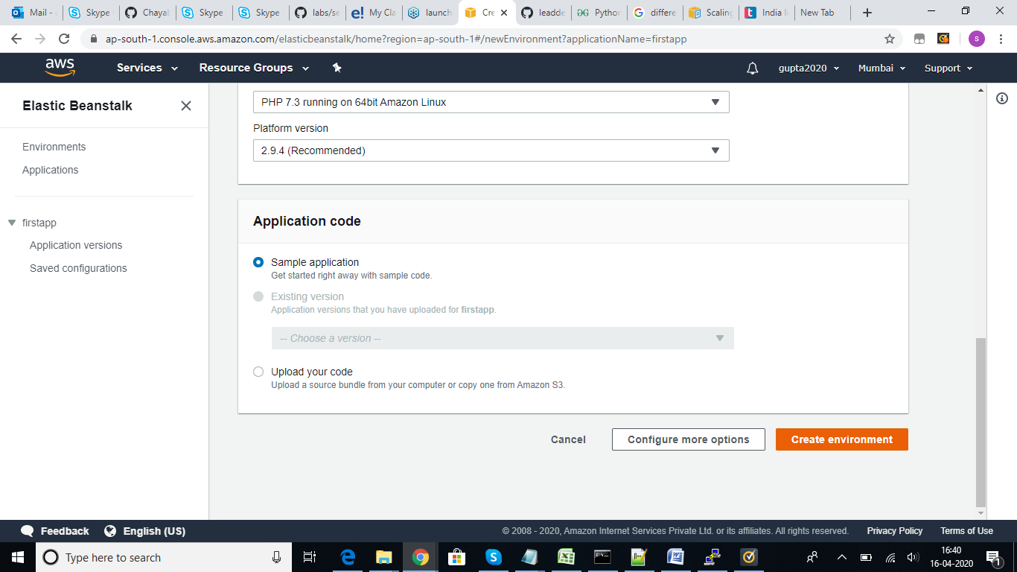

Once the environment is created and application is up…we will get the page as below and we can access the url to check the status of application.

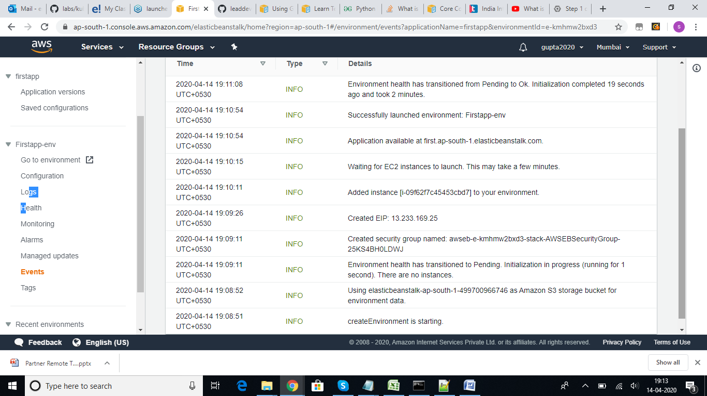
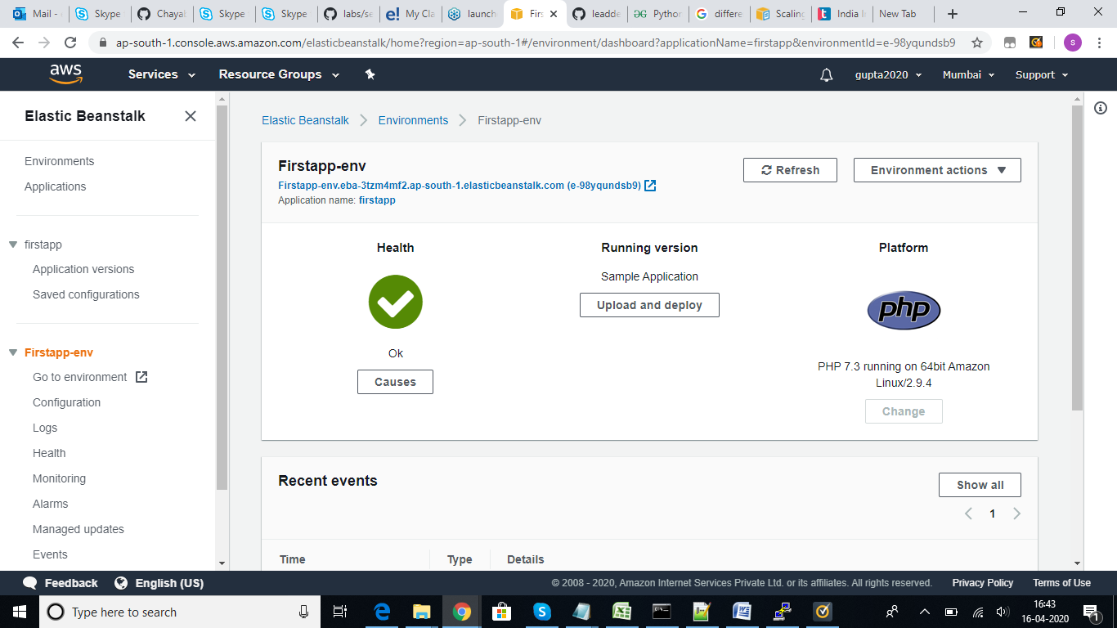

We have the navigation pane on the left handside, if we wanted to change instance type, auto sclaing, cloudwatch, add any data base, notifications, want to setup our own network on vpc, security groups etc. We can perform all these action in configuration page,

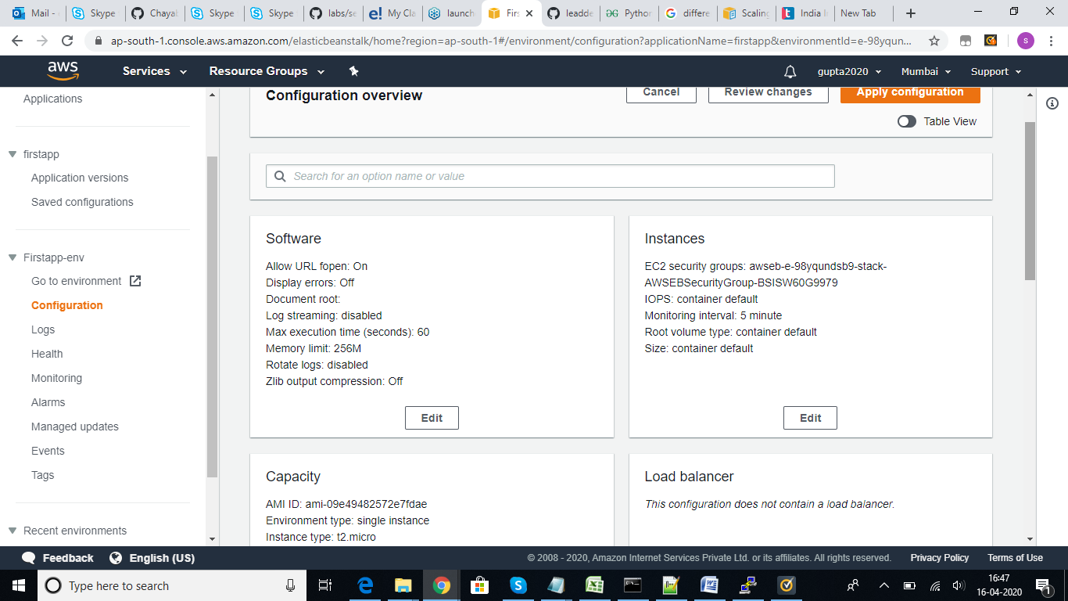

Environment actions:
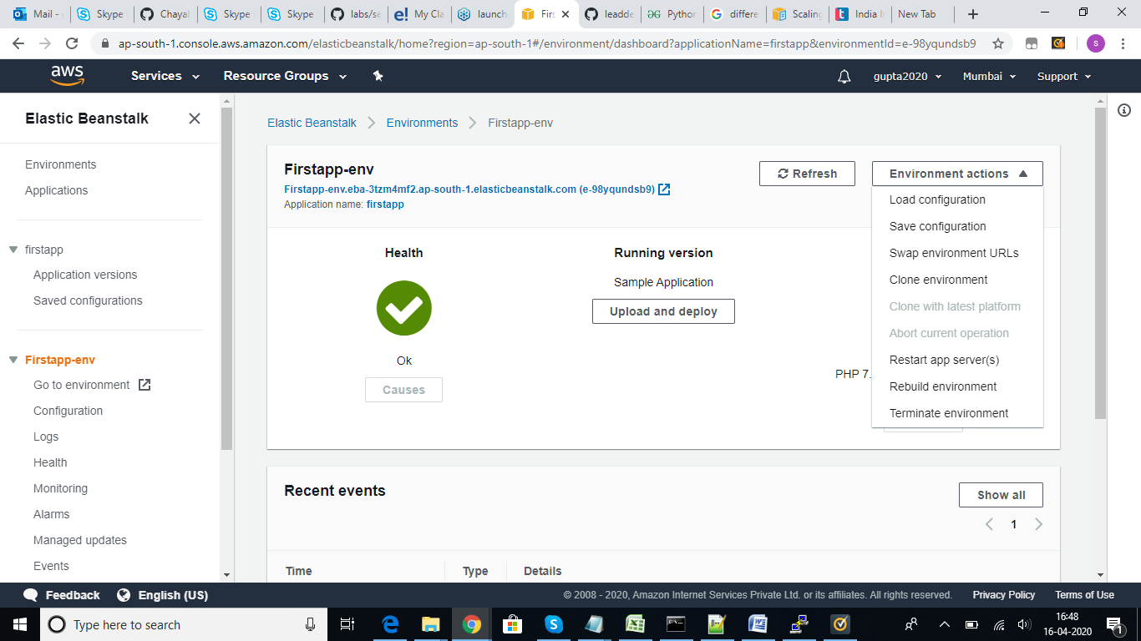

Under environment actions there are multiple options available, based on our requirement we can use the options. Ex: we can save these configuration and use these to load and create new environment.
We have options to terminate environement, restart app server etc.

